|  |
| --- |
| Healthcare system  Design |

|  |
| --- |
| RTOS – Design |

|  |  |
| --- | --- |
| Hossam Elwahsh  hossam.e.elwahsh@gmail.com |  |

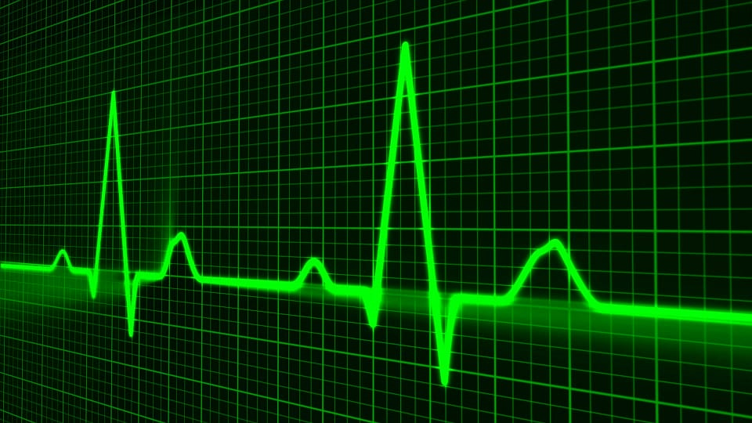

CONTENTS

System Analysis 2

Requirements 2

Tasks Layout 2

Calculations 3

System Tick 3  
 Hyperperiod 3

CPU Load 3

Notes: 3

SimSo Model 4

SimSo Results 4

|  |
| --- |
| System Analysis |

|  |
| --- |
| Requirements Required to design a healthcare system using RTOS, consisting of a touch LCD connected with UART, Blood pressure sensor, heart beat detector, temperature sensor and an alert siren. Tasks Layout |
|  |

## System Tick

∴ Systick = 12 ms

|  |
| --- |
| Calculations |

**Hyperperiod**

**CPU Load**

**Notes:**

The assistance of the SimSo model is necessary for predicting system schedulability, given the periodicity of the temperature sensor task (5ms) and its execution time (2.5ms). Manual handling of this task would overcrowd the timeline and complicate visualization. However, excluding this particular task, it becomes evident that the system is schedulable. By employing appropriate prioritization decisions, the system can effectively accommodate the temperature sensor task without compromising the deadlines of other tasks.

**SimSo Results**

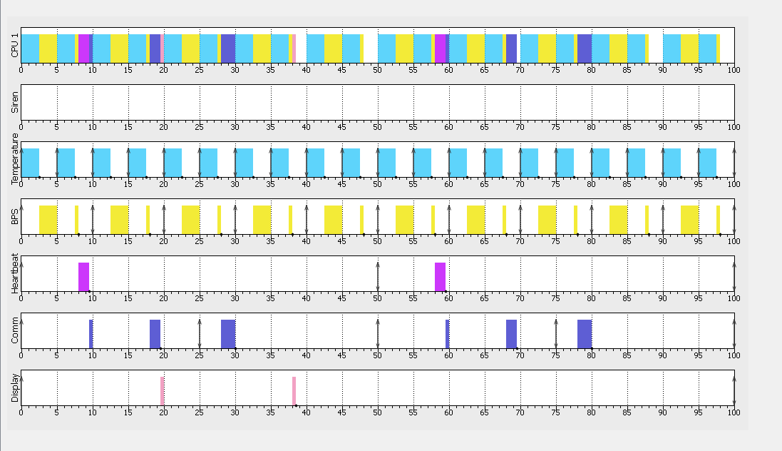

|  |
| --- |
| SimSo Model |

|  |  |
| --- | --- |
| CPU Load | Response Time / deadlines assurance |
|  |  |